**AWS: EC2- Linux instance connecting via putty while converting pem to ppk**

Key-pair is like password

Check the users in key-pair if not connecting and remove unwanted users as per requirement

Ppk- for accessing via putty

Pem- For openSSH

For accessing via putty a pem will need to convert pem to ppk

To convert pem key into ppk:

Goto> puttygen> Load>select:All files from the drop down[refer screenshot]>select the key> save private key> give a name

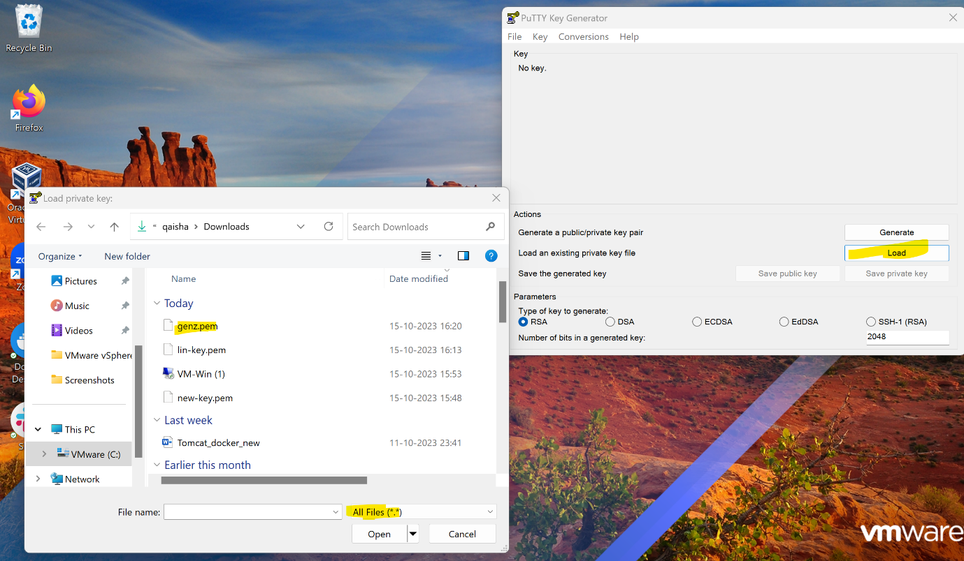

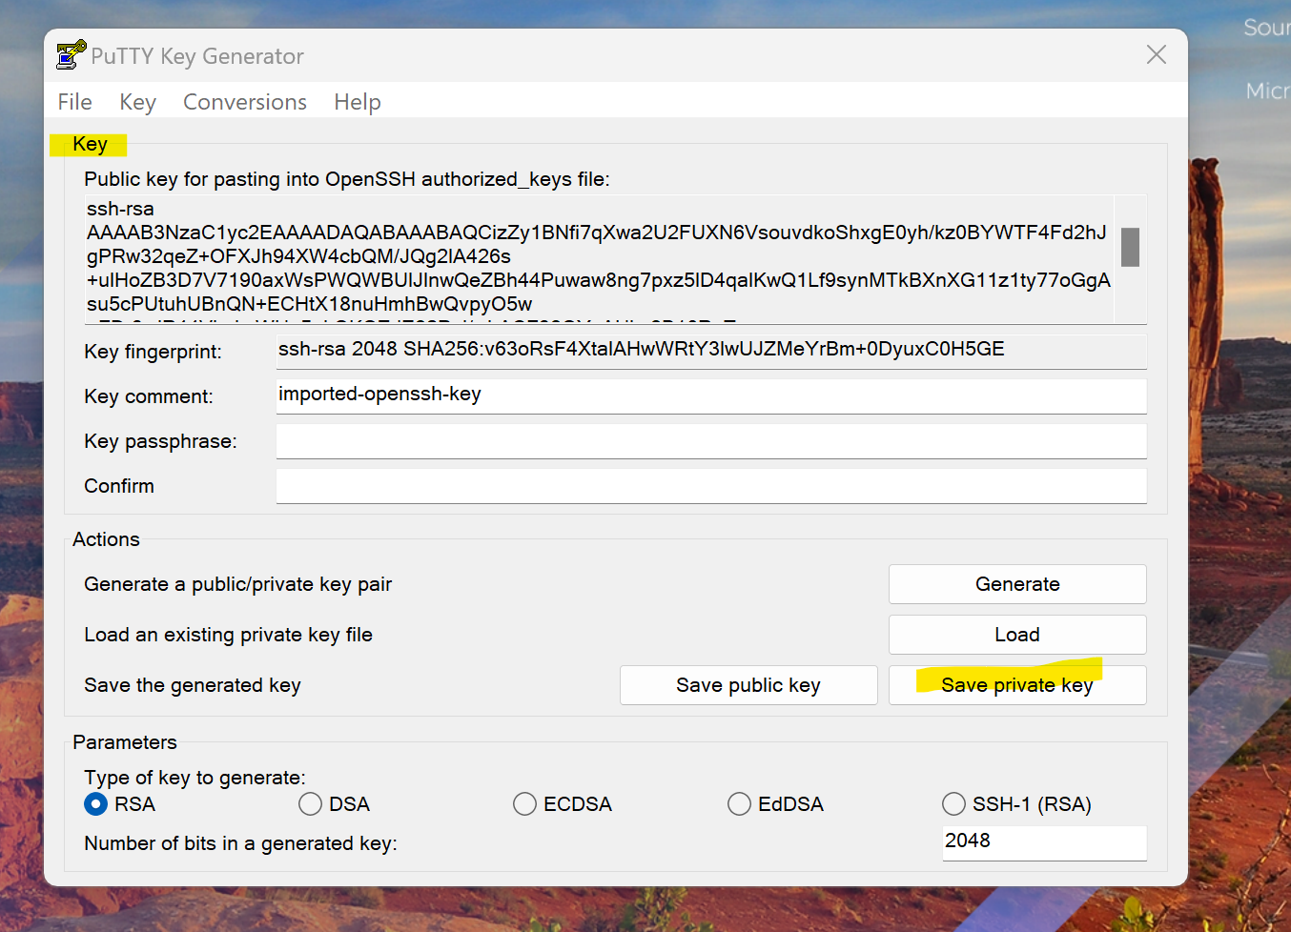

Now make a note of public IP of EC2 instance

Goto putty> put in IP> from dropdown select SSH >Auth> credentials> select ppk converted saved key as below

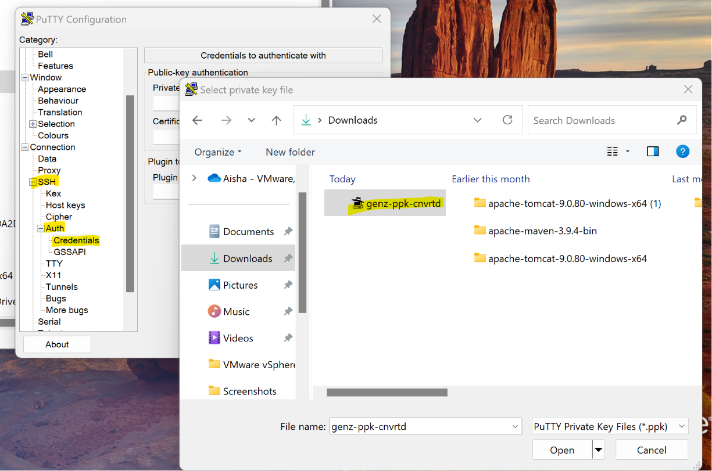

Login as ec2-user> you will be connected as below:

